BoR (10) 47

Electronic communications services: Ensuring equivalence in access and choice for disabled end-users

PUBLIC CONSULTATION

11 October – 26 November 2010

October 2010

Table of Contents

Executive Summary 5
1. Introduction 8
1.1 Background 8
1.2 Purpose and scope of the paper 9
2. The current legal framework and associated measures in place in MS 11
2.1 Current status of provisions for end-users with disabilities under USO 11
2.2 Measures currently in place for end-users with disabilities under USO 13
2.3 Initiatives outside the scope of USO 18
2.4 The role of general legislation with respect to end-users with disabilities in MS 20
2.5 The anticipated role of Article 23(a) (1) with respect to measures for end-users with disabilities in relation to electronic communications 21
3. Equivalent access and choice; factors for consideration 23
3.1 Assessing Equivalent Access 23
3.2 Assessing equivalent choice 30
3.3 Encouraging availability of terminal equipment 34
3.4 Assessing the needs of end-users with disabilities 36
4. Services and features available for end-users with disabilities 38
4.1 Services for users with disabilities: details of the services available or required 38
4.2 Features for end-users with disabilities: details of features available/required 40
4.3 Payphones: details of the measures for access to payphones and services from payphones for end-users with disabilities 42
4.5 Funding and provision of subsidies for services for disabled end-users 46
5. Proposed approach to achieve equivalent access and choice 51
5.3 Identify proportionate measures to address issues with respect to equivalence 53
5.4 Consult with interest parties regarding proposed measures and obligations on undertakings; 54
List of countries where services and features are reported as provided (Section 4) 58
Glossary of terms 60
References 63

Table of Figures

Figure | Page
Figure 1 Special measures for users with disabilities in relation to electronic communications | 14
Figure 2: What is the most important factor with respect to assessing equivalent access? – Access to and use of the electronic communications service | 24
Figure 3: What is the most important factor with respect assessing to equivalent access? – access and use of the services associated with the use of the electronic communications service | 28
Figure 4: What is the most important factor with respect assessing to equivalent choice? – range of service providers with accessible services | 30
Figure 5: What is the most important factor with respect assessing to equivalent choice? – being able to exercise choice | 33
Figure 6: What would your NRA consider appropriate ways of encouraging the availability of terminal equipment . . . .? | 36

Executive Summary

Background to Amending Directive

In 2007, the European Commission (EC) undertook a review of the European legislation with respect to the electronic communications rules. During this period of review, the EC issued a communication (EC, 2007), in respect of its reform of the European electronic communications rules, which had been established in 2002. While recognising that many advances had been implemented for consumers since the Telecoms Rules were first introduced, the EC outlined a number of key areas where it proposed to put in place improved consumer protections. Among other changes, detailed in the section entitled ‘Empowering European consumers’, the paper signalled ‘improved accessibility for users with disabilities’ to ensure that consumers with disabilities can benefit from greater access to electronic communications services.

As new technologies emerge and methods of electronic communications become more varied and widely used by all consumers, BEREC recognises that the availability of, and access to, electronic communications services plays an important role in promoting social inclusion. According to the EC communication regarding e-Accessibility COM(2005) 425 people with disabilities represent 15% of the European population. Additionally, the European Disability Forum (EDF) states that ‘disabled people suffer from isolation compared to non disabled people’. Therefore, BEREC considers that the provision of access to and choice of electronic communication services for consumers with disabilities is becoming increasingly important to ensure that all consumers can benefit from new communications services and fully participate in the Information Society.

After a period of review by the EC, a revised ‘Telecoms Package’ was agreed and published in December 2009. As part of the new Telecoms Package, the legislation with respect to Universal Service (US) known as the Universal Service Directive (USD) was reviewed. Directive 2009/136/EC (the 2009 USD), contains a new Article (Article 23a) entitled ‘Ensuring equivalence in access and choice for disabled end-users’.

Objective of this consultation

When transposed, it is likely that, in most cases, National Regulatory Authorities (NRAs) will be responsible for implementing at least some aspects of Article 23a of the USD. In preparing to implement Article 23a, it is envisaged that many NRAs could benefit from more extensive knowledge relating to current measures through collation of information from NRAs and via public consultation. A number of examples and best practices developed within MS are presented throughout this document. Therefore, this consultation is being conducted with a view to finalising and publishing a BEREC paper for the purposes of providing enhanced information for NRAs with respect to the considerations regarding the implementation of Article 23a that, following its transposition, it is envisaged NRAs will assume responsibility for.

The objectives of this consultation are outlined below:

- to present information collated from NRAs regarding the current measures in place in MS;

- to present the preliminary views of NRAs with respect to assessing and implementing equivalent access and choice, and

- to seek the views of interested parties including consumers, end-users with disabilities, representative organisations, and service providers.

Structure of the paper

The paper is divided into 5 sections:

- Section 1 introduces the paper, its background and its scope and purpose;
- Section 2 provides an overview of the current legislative measures in place in Member States (MS) in respect of end-users with disabilities in relation to electronic communications;

- Section 3 outlines the preliminary views of NRAs with respect to assessing equivalent access and choice;

- Section 4 provides an overview of the current services, features and terminal equipment available in MS for end-users with disabilities;

- Section 5 outlines a proposed approach with respect to the implementation of equivalent access and choice with respect to electronic communications services.

Next Steps
BEREC welcomes responses from all interested parties. In order to facilitate that responses can be fully analysed, respondents are requested to provide any available information that may help to illustrate and support their response. Following the consultation period, BEREC will analyse and consider the responses received prior to issuing its final report with respect to Article 23a of the USD (Ensuring equivalence in access and choice for disabled end-users).

1. Introduction

1.1 Background

After a period of review of the Telecoms Package, the EC introduced amending legislation with respect to the USD. The amending legislation, Directive 2009/136/EC was published in the Official Journal (OJ) on 18 December 2009 (the 2009 USD). Among other changes, the 2009 USD had the effect of amending Directive 2002/22/EC (the 2002 USD). This legislation must be transposed into national legislation within MS by 25 May 2011.

The 2009 USD, contains a new Article, (Article 23a), entitled ‘Ensuring equivalence in access and choice for disabled end-users’. Article 23a contains two sections;
- Section 1 relates to equivalent access and choice for disabled end-users and;
- Section 2 relates to encouraging the availability of terminal equipment.

The EC communication on e-Accessibility 2005 COM(2005)425, states that ‘the Commission has the ambitious objective of achieving an “Information Society for All”, promoting an inclusive digital society that provides opportunities for all and minimises the risk of social exclusion’. In relation to electronic communications, the intention of the new Article 23a is to ensure that end-users with disabilities, estimated at 15% of the European population, can more fully participate in and benefit from technological advances and developments in electronic communications that are available to other end-users.

Currently, in most MS, provisions with respect to access to services for end-users with disabilities apply predominately to the Universal Service Provider (USP). However, the provisions of the new Article 23a(1) allow MS to enable NRAs to specify requirements to be met by undertakings providing electronic communications services to ensure that disabled end-users have equivalent access to and choice of undertakings and services that are available to the majority of end-users. Therefore, in addition to the provisions for end-users with disabilities already in place in MS, under Universal Service Obligation (USO), Article 23a provides a mechanism to apply relevant obligations to all electronic service providers.

Article 23a(2) specifies that MS shall encourage the availability of terminal equipment offering the necessary services and functions. However, it is not yet clear, because it depends on the way in which Article 23a is transposed in individual MS, if, and to what extent, NRAs will have responsibilities with respect to the provisions of Article 23a(2).

It is foreseen that there may be a number of challenges for NRAs with respect to their particular responsibilities in relation to Article 23a, including the establishment and implementation of an effective approach to the following related tasks:

- Collating information regarding the needs of electronic communications end-users with disabilities with respect to equivalent access and choice;
- Assessing whether or not access and choice for end-users with disabilities is equivalent;

- Identifying and implementing measures to address issues identified with respect to ensuring equivalent access and choice; and

- Ensuring that obligations placed on service providers are proportionate to the objectives.

It should be noted that because standards for equipment are set at a European level, it is not possible for individual MS to establish standards of their own.

1.2 Purpose and scope of the paper

BEREC is conducting this consultation with the view to assisting NRAs to develop an approach to the key issues relating to the provisions of Article 23a.

In order to develop this consultation paper, BEREC has drawn on the inputs of its members to identify and understand national conditions, current practices and the preliminary views of NRAs. To achieve this, BEREC developed and circulated a questionnaire to all members and responses were received in April and May 2010. The questionnaire received a very positive response from NRAs, with 23⁽⁾ countries responding, although not all questions were completed by all respondents. The questionnaire was structured to collate input from NRAs in relation to the following:

- The legal framework with respect to electronic communications in place in MS,
- NRAs preliminary views with respect to implementing equivalent access and choice and facilitating the availability of terminal equipment, and
- The current measures in place in relation to electronic communications for end-users with disabilities.

In addition to the preliminary views and available information received from NRAs, BEREC recognises that there may also be relevant information available from other bodies or organisations. Therefore, BEREC welcomes inputs with respect to the consultation questions raised to ensure that it can analyse and reference the most relevant and current information available with respect to end-users with disabilities in relation to electronic communications services. This consultation paper sets out to achieve the following objectives:

- to present information collated from NRAs regarding the current measures in place in MS,

- to present the preliminary views of NRAs with respect to assessing and implementing equivalent access and choice, and

- to seek the views of interested parties including consumers, end-users with disabilities, representative organisations, and service providers.

This consultation relates solely to the provisions of Article 23a, which are specific to electronic communications. While examples are provided, this paper is not intended to specifically address particular accessibility issues relating to particular provisions being put in place under Article 26 in MS for equivalent access to emergency services. The paper is not intended to address the accessibility of content in relation to broadcasting.

2. The current legal framework and associated measures in place in MS

This section aims to provide an overview of the current legal framework and associated measures, with respect to electronic communications, in place in MS, specifically relating to end-users with disabilities. The information presented is based on the responses, completed by NRAs, to the BEREC questionnaire regarding accessible electronic communications.
In general, according to the information provided, NRAs’ powers in respect of the regulation and imposition of provisions on undertakings regarding disability measures are predominantly in relation to the USO.

An additional point to note is that Roaming Regulation (Regulation (EC) No. 544/2009), mandates home providers to provide blind or partially-sighted customers with basic personalised pricing information automatically, by voice call, free of charge, if they so request (article 6, paragraph 1, b).

2.1 Current status of provisions for end-users with disabilities under USO

2.1.1 Provisions in place under the 2002 USD

Article 7(1) of the 2002 USD provided for ‘special measures for disabled users’ with respect to provision of ‘access at a fixed location’ and ‘directory enquiry services and directories’ in accordance with the USO.
Article 6 of the 2002 USD also contained a provision regarding the accessibility of public pay telephones to disabled end-users based on the ‘reasonable needs of end-users’.

In addition, the provisions of the Article 7(1) of the 2002 USD relate to the affordability of US. The provisions for end-users with disabilities established by Article 7(1) are focused primarily on services provided under US by the USP(s) and therefore they are designed to ensure access to US (predominately provided via fixed line) for end-users with disabilities. However, Article 7(2) also provides that MS ‘may take specific measures’ so that end-users with disabilities ‘can also take advantage of the choice of undertakings and service providers’.

In general, since 2002, the 2002 USD has set the scope for provisions within MS regarding access to, and affordability of, publicly available telephone services for end-users with disabilities.

With few exceptions, the provisions are implemented and monitored by NRAs. Specific measures for end-users with disabilities and the rules concerning the affordability of the US are mainly laid down by decrees or NRA decisions.

Exceptions to this arise where there are no specific provisions relating to end-users with disabilities provided for under USO. In such cases, the legislative framework with respect to the general approach to implementing the USO, and the designation of the undertakings is defined by or in collaboration with the corresponding ministry.

The current status regarding the measures in place with respect to US, including those in relation to end-users with disabilities, in BEREC countries is also presented in the “BEREC Report on Universal Service – reflections for the future”: BoR 10(35).

2.1.2 New provisions for end-users with disabilities under the 2009 USD

The 2009 USD provides for additional measures for end-users with disabilities to be implemented, particularly with respect to equivalent access and choice.

Most notably, the new Article 23a (1) – ‘Ensuring equivalence in access and choice for disabled end-users’ specifies that national authorities shall be enabled to specify the requirements to be met by service providers providing electronic communications services to ensure access and choice equivalent to that enjoyed by the majority of end-users.

Article 23 a(2) states that ‘. . . .Member States shall encourage the availability of terminal equipment offering the necessary services and functions’.

In addition, the new Article 21(3) (f) of the 2009 USD provides that relevant national authorities may oblige undertakings to regularly inform disabled subscribers of details of products and services designed for them. The amendments outlined above are further supported by revisions to Article 7 of the 2009 USD, concerning services provided under US, to ensure equivalence of access and affordability, and specifying that national authorities may be obliged by MS to assess the general need and specific requirements of measures in relation to US for end-users with disabilities.

2.2 Measures currently in place for end-users with disabilities under USO

Figure 1 shows the specific measures, already in place, according to the information provided by the NRAs and other available information, predominantly as a result of the implementation of the provisions of the 2002 USD, in relation to ensuring access to and affordability of services provided under the USO.

In Sweden, specialist terminal equipment, relay services, accessible bills, accessible information, special directory enquiry services and accessible emergency services are also made available using alternative mechanisms, as there is no USP. The Swedish NRA procures important services such as text and video relay and directory services while operators are obliged to provide accessible bill formats.

Figure 1 Special measures for users with disabilities in relation to electronic communications
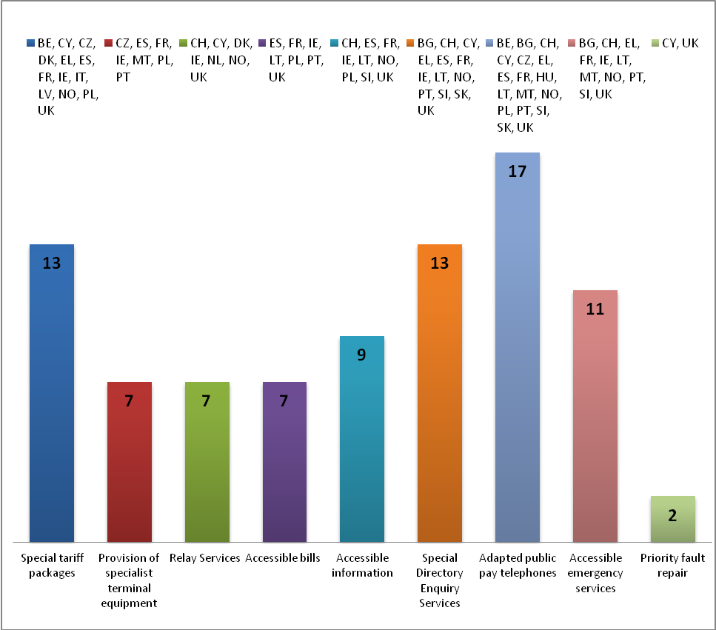

2.2.1 Accessibility of US

Regarding the accessibility of the US to end-users with disabilities, NRAs reported that a range of obligations are imposed on the USPs within MS including:

- provisions regarding the availability of specialist terminal equipment (such as phones with amplifiers, phones with visual alerts for incoming calls, phones that allow end-users to plug in hearing aid units, speed dialling and hands-free or loudspeaker options on handsets for customers who have difficulty using their hands, telephones with large buttons or other options for end-users with low vision) and special prices for rental or for the purchase of special terminal equipment;

- provisions regarding implementing special services for end-users with disabilities to ensure access to publicly available telephone services, such as text relay services, priority fault repair services, web-based text phone services;

- provision of billing and contractual information in accessible formats for different types of disabilities (for example, audio format or Braille upon request), the provision of information desks and switching services for people with vision impairments.

Example: Poland – special services

Since March 24 2005, the Ordinance of The Minister of Infrastructure contains obligations related to points of sale (shops and sales offices), the ways of making contracts, regulations, price lists and bills accessible to end-users with disabilities:

a) in the shop or sales office supporting users of the designated undertaking, there must be a specially signposted, private position designed to support end-users with disabilities, equipped with a text message device (computer) allowing contact with deaf or non-talking persons;
b) each of the designated undertaking’s shop or sales office, mentioned in point a), is accessible to people with physical disabilities;
c) there should be information about places with installed public pay phones adapted for use by end-users with disabilities in designated undertaking shops or sales offices and on its website and the information should be updated at least once per quarter;
d) on request of a blind or partially sighted person, the information on the invoice, including the basic list of telecom services, should be produced in Braille or in a large-print format or it should be sent by e-mail in text format;

e) the designated undertaking must make available in its shops and sales offices large-print or electronic versions of prices and terms and conditions upon request of blind or partially sighted persons;
f) on request of a blind or partially sighted person, the detailed lists of telecommunications services should be available in a large-print format.

- most respondents referred to the general provisions regarding the availability and use of public pay telephones by end-users with disabilities under the USO, such as the obligation imposed on the USP to install a sufficient number of public payphones that allow access and use for persons with disabilities to public payphones or to mark telephone cards in a manner allowing independent use by end-users who are blind or visually impaired.

Examples: public pay telephones

In France, the adaptation of public pay telephones for end-users with disabilities consists of:
- Blind and visually impaired – a special button on payphones for that category of disability, voice server with pricing information;

- Deaf, hearing impaired and people with speech problems - key "listening", text public telephones (called « Publiminitels »);

- ‘Locomotor’ Disabled - devices without door, with lowered position or with a larger host.

In Portugal, under the Electronic Communications National Law, the USP is mandated to ensure universal access, when installing a new public payphone, the USP shall promote compatibility with the technical rules on access to urban buildings, to ensure, access to the service by end-users with disabilities;

In Lithuania the universal service provider shall ensure that;
- the instructions regarding how to use public payphones is written in no smaller than 16 size fonts and is illuminated when it is dark;
- the installation of public payphones complies with the requirements for the construction of public payphone cabin or construction of other public payphone service place for disabled users,
- the total number of such public payphones is no less than 10 per cent of all the public payphones,
- the at least one textual public payphone is installed at each disabled rehabilitation centre.

- provisions regarding access to directory enquiry services and directories, equivalent to that enjoyed by other end-users consist mainly of directory enquiry services free of charge for blind or visually impaired people and an accessible format of the directory for the end-users with disabilities (for example, on DVD);

- Other examples listed below, detail relevant provisions that are designed to ensure the accessibility of electronic communications.

Examples: other measures

Norway: Providers under a USO shall ensure that research and development connected with such services is continued. Telenor (USP) shall annually provide the Norwegian Post and Telecommunications Authority a report on the status and current projects in this area.
Sweden: The Swedish Regulator, finances projects that develop new communications solutions for persons with disabilities within electronic communications. Examples of this include the SMS 112 project (access to emergency services), streaming to mobile of audio books and papers.

Denmark: It is a USO to provide a web-based text phone service and a PC-based text phone service, and internet access is provided as part of this service. The US includes a broadband connection with a speed of minimum 512/512 Kbit/s to certain groups of disabled end-users (deaf, deaf-blind, etc.).

2.2.2 Affordability measures

Regarding the provisions that are designed to ensure affordability of the US to end-users with disabilities, several respondents referred to financial facilities, such as social tariffs, discounts or special packages for end-users with disabilities, or other vulnerable end-users (low income, elderly people, etc.) that in the main also include users with disabilities.

The most common measure reported is the existence of special tariff packages, which depart from those provided under normal commercial conditions, resulting in discounts in relation to the monthly subscription. In such cases, any established net cost of providing the service is covered by the US fund or state budget.

In addition, as previously stated, some MS reported other cost related measures for certain categories of end-users with disabilities, such as preferential text (SMS) packages for those with hearing impairments, preferential prepaid packages for those with visual or hearing impairments, special tariff plans or a rebate scheme for deaf or end-users with serious auditory difficulties (the rebate applies to the calls involving a text phone device and where the call is established through the a Text Relay Service).

Example: Belgium - social tariffs for people with disabilities

In Belgium, all operators (including mobile operators) must apply the social tariffs to those customers that meet the legal criteria specified. A special US fund for the social tariffs is financed by the fixed and mobile telephony service operators and is administered by the Belgian Institute for Postal Services and Telecommunications.

2.3 Initiatives outside the scope of USO

Outside the scope of the USO, only Ofcom (UK) has imposed obligations on all undertakings with respect to provision of measures for end-users with disabilities. In some cases, however, NRAs have undertaken initiatives to introduce measures using other means such as:

- implementing measures for specific services and service providers;
- developing and implementing codes of practice;
- promoting dialogue with interested stakeholders;
- mediation between communication service providers and organisations representing end-users with disabilities.

Example: Ireland – Forum on electronic communications services for people with disabilities
The Irish Regulator, ComReg, chairs a Forum on electronic communications services for people with disabilities, established to further ComReg’s statutory objectives to promote the interests of end-users. The initiatives pursued by the Forum are intended to address the primary issues experienced by end-users with disabilities including access to a special directory enquiry service from operators other than the USP, accessible bills and accessible operator websites. In 2007, and again in 2010 the Forum developed and conducted a survey of people with disabilities in relation to electronic communications services. The Forum also developed a consumer guide entitled, ‘Phones and Broadband – a guide for people with disabilities and older people’. The guide was made available in various accessible formats including large print, Braille and audio.

On the other hand, some NRAs, based on provisions of general accessibility legislation, promote the rights of end-users with disabilities in the electronic communications sector by imposing obligations on providers of electronic communication services other than the USP(s). These NRAs have issued decisions to regulate specific issues, relating to electronic communications, to address the needs of specific social groups, in particular, end-users with disabilities.

Examples:
In Germany, there are no provisions under USO for end-users with disabilities. However, in the German Telecommunications Act, there are regulations for disabled end-users. For example, The Federal Network Agency issued an administrative order introducing a text and video relay service for deaf and hearing-impaired persons. (Section 45 of TKG (German Telecommunications Act);

In Italy, the NRA, under the Law 481 of 14 November 1995 that establishes norms of governing competition and the regulation of public utilities and the institution of regulatory bodies for public utilities, is entitled to issue decisions that contain specific provisions mandatory to all undertakings. Agcom has introduced a free service or a special price for services for disabled end-users: 50% discount in the internet service monthly fee - or the equivalent of 90 hours of internet connection free - for blind people. It is also planned that a free telephone monthly fee for deaf people and their family and free fixed price plan cost for SMS service will be introduced. (Agcom decision n. 514/07/CONS and the following n.. 182/08/CONS).

Another example of a legal framework that allows the NRA to impose obligations regarding disabled end-users on all undertakings, based on the US legislation (an extension of the US provisions) is the UK. Based on the USD’s provisions, some obligations were laid down in the General Conditions of Entitlement, meaning that the provisions concerning disabled end-users are applicable to all providers of publicly available telephone services or public telephone networks, not just to the USP. (Section15. Special Measures for end-users with Disabilities).

2.4 The role of general legislation with respect to end-users with disabilities in MS

General legislation in MS concerning the rights of end-users with disabilities can influence the approach by NRAs or other governmental bodies' policymaking in relation to the electronic communications sector, even in cases when specific provisions concerning the electronic communications sector may not exist.

In Switzerland, the Act for the equality of disabled people establishes the framework for the promotion of equality, including the designation of an office (Federal Bureau for Equality of People with Disabilities) to survey and suggest specific changes to the legislation in various sectors.

In the UK, Ofcom is required, under equality legislation, to have a single equality scheme that governs how it operates, both as an employer and as a public body, in the areas of disability, gender and race. This requires Ofcom to carry out an equality impact assessment of every policy undertaken.

In fact, due to national conditions, in many cases the responsibilities of regulating and promoting a legal framework that enhances the rights of disabled end-users in the electronic communications sector are shared with other bodies, such as government departments, social protection organisations, disability authorities etc. These bodies can act with a more general legal basis (non-discriminatory laws, general social protection and work regime provisions) that include measures related to end-users with disabilities access to electronic communications services.

In general, the NRAs reported that the provisions implemented by other bodies relate to financial assistance from local authorities or government bodies, subsidies for terminal equipment, and the prohibition of discrimination such as refusal to supply or provide any goods or services based on a user’s disability.

Example: In Finland, the provision of services and support measures for the disabled is the responsibility of local authorities.
Under the Disability Services Act, the municipality must ensure that the services and support for end-users with disabilities are organised. An individual client's need for assistance shall be taken into account when organising services and support under this Act. The consumer with a disability may receive compensation for the costs related to tools, machinery and equipment necessary to perform daily activities. Finland's Slot Machine Association (RAY) was established to raise funds through gaming operations to support Finnish health and welfare organizations. RAY’s Funding Activities department monitors and checks how the funding assistance is used. The Ministry for Social Affairs and Health directs and monitors RAY’s funding activities, including the completion of the distribution proposal and assistance plan, payment of funding assistance and monitoring of its usage.

2.5 The anticipated role of Article 23(a) (1) with respect to measures for end-users with disabilities in relation to electronic communications

It seems apparent, from the information provided by NRAs, that the measures required to be implemented under Article 23(a) (1) to ensure equivalent access and choice will vary between MS, primarily because of varied measures and conditions existing in MS.
Therefore, Article 23(a) can play a role within MS, through NRAs, to ensure equivalent access and choice for end-users with disabilities in respect of electronic communications where it is found that existing measures and national conditions do not deliver this.

Consultation Question 1: Are there additional legal provisions, other than those listed in Section 2, currently in place in MS with respect to users with disabilities regarding electronic communications? If yes, please detail the provisions and the organisation responsible for implementing or monitoring these provisions.

3. Equivalent access and choice; factors for consideration

Prior to implementing measures to ensure equivalent access and choice under Article 23a, MS must first establish whether or not there is equivalence and subsequently identify any factors that need to be addressed.

BEREC proposes that “equivalent” in this context means that equal access to and choice of electronic communications services should be achieved for end-users with disabilities, albeit that this might be achieved in different ways for end-users with disabilities in comparison with other end-users.

In order to assess if access and choice is equivalent for end-users with disabilities, the status with respect to other end-users should be known, so that comparisons can be drawn and any issues, as relevant, identified and highlighted.

Notwithstanding that, in accordance with Article 33 of the 2002 USD, NRAs shall consult with interested parties with respect to decisions regarding end-users interests, the sections outlined below are proposed to provide guidance to NRAs regarding the assessment of equivalent access and choice in their Member State.

As detailed in section 2.2, MS have put in place a range of measures for users with disabilities, under US. A question arises with respect to these measures, which MS (together with NRAs in some cases) have already deemed necessary to ensure access to services under US. A possible consideration for MS is whether equivalent choice could be achieved by the application of the accessibility measures, currently provided by the USP, to some or all other undertakings.

3.1 Assessing Equivalent Access

When asked which factors are deemed important, and to what degree, when assessing equivalent access for end-users with disabilities, NRAs highlighted two components of equivalent access as below:
- the user’s capacity to access and use the electronic communications service in an equivalent way to other end-users;
- the user’s capacity to access and use services associated with the use of an electronic communications service in an equivalent way to other end-users.

3.1.1. The user’s capacity to access and use the electronic communications service in an equivalent way to other end-users

Access should be functionally equivalent, in order that disabled end-users benefit from the same usability of services as other end-users, even if by different means.

As illustrated in figure 2 below, in NRAs’ preliminary view, of one of the most important factors is the availability of accessible terminal equipment. Also important in this respect are factors such as price, the number of suppliers and additional setup necessary for end-users with disabilities.

Figure 2: What is the most important factor with respect to assessing equivalent access? – Access to and use of the electronic communications service

Availability of accessible terminal equipment

In the preliminary view of 12⁽⁾ NRAs, the availability of terminal equipment is a very important item for consideration when assessing equivalent access. Without appropriate terminal equipment for end-users with disabilities, the use of an electronic communications service may not be possible.

For example, to be able to use a mobile phone, a person with vision impairment may require certain voice output features such as talking menus and a text message to speech conversion feature. For others, large button phones may assist in the case of an end-user with a visual impairment or reduced dexterity. End-users with hearing loss may require handsets that are compatible with their hearing aid. It is also noted that more often, particularly in the case of mobile handsets, features that are beneficial to end-users with disabilities and in some cases necessary for use of the service are available with mainstream handsets.

The concept of Design for All (DfA)- which refers to the design and composition of an environment so that it can be accessed, understood and used to the greatest extent possible by all people, regardless of their age, size or disability - is particularly relevant in this context.

Price
A consideration regarding terminal equipment is its price.
11⁽⁾ NRAs preliminary view was that in assessing equivalence, price is a key consideration (figure 2). While recognising that not everybody can afford the handset they would like, with features such as camera, radio, MP3 player, internet access etc., it is considered important that end-users with disabilities should be able to acquire, with financial assistance if appropriate, handsets or terminal equipment with the features that they need in order to access the electronic communications service that they need to use it for. For certain electronic communications services, as universal design becomes more prevalent, accessibility features become mainstream and the requirement for specialised handsets decreases. This means that the instances where end-users with disabilities have to pay additional costs, when compared with other end-users, to purchase accessible handsets, are minimised.

In addition to the considerations regarding the price of specialist terminal equipment, it is important that end-users with disabilities should not have to pay additional charges to use the same electronic communications services as other end-users.

However, it is also recognised that different services may be required for end-users with disabilities, to ensure equivalent access, such as a text relay service. In this case, it is important to recognise that such a service may have a cost associated with it. In this case, the question arises with respect to who should pay for the additional cost if services for end-users with disabilities are to be provided at an equivalent price to that charged to other end-users using comparable services.

Example: UK rebate scheme for people with hearing disabilities

In the UK, all communications providers must give their customers access to an approved text relay service. They must also ensure that customers who make calls using the text relay service are charged no more for these calls than if the call had been made without the relay service. Because calls using the text relay service take longer than other calls, most providers meet this condition by giving customers a rebate on these calls. The amount of the rebate is not set by the regulator, but is typically 50-60%.

When assessing if price is equivalent for end-users with disabilities it should also be taken into consideration that all end-users have preferred methods of communications. Packages may not reflect these preferences exactly (e.g., some end-users may prefer texting (SMS). However, mobile operators may not offer SMS only packages and it is necessary for these end-users to buy packages that also have voice call minutes included, which they may not fully use.

Keeping this in mind, it is important to analyse if, for example, this scenario is equivalent for people who have speech or hearing disabilities and, as a result, may wish to choose packages with texts included rather than voice minutes. It is necessary to establish if there is price detriment for end-users with disabilities, when compared with similar scenarios for other end-users (e.g. is there detriment in terms of price, compared to other end-users, if an end-user with a disability pays for a package with voice minutes included that he/she cannot use).

The number of suppliers and additional set up

When assessing equivalence of access, it may be necessary to ascertain the number of different suppliers that end-users with disabilities need to contact in order to purchase their service and commence using it. In the data collated from NRAs there are varying views with respect to the importance of the number of suppliers/additional set-up when assessing equivalent access (figure 2).
In some cases, the set-up process may be more complex for end-users with disabilities as they have to contact additional suppliers to purchase or acquire the terminal equipment and to set up specialist software or to configure the terminal/handset in a particular way. It may be the case that if the features required by a person with a disability are not standard features, then the communications service provider may not have expertise or knowledge in this area and may not be able to assist the consumer.

This additional effort may dissuade end-users with disabilities from accessing a service or indeed switching their service provider. However, ideally, end-users with disabilities should be able to access the electronic communications service with similar ease as other end-users. In assessing this factor, it is important to consider also the following:

- how often end-users with disabilities need to carry out particular set-up or configuration;
- whether it is easy for end-users with disabilities to ascertain who to go to for assistance with set-up;
- whether contacting two or more suppliers each with particular expertise creates a barrier with respect to access for end-users with disabilities.

3.1.2. Being able to access and use services associated with the use of an electronic communications service in an equivalent way to other end-users

Figure 3 illustrates that NRAs are of the preliminary view that as well as accessing the electronic communication service itself, also of importance is the ability to access and use the services associated with the use of the electronic communications service, such as customer support & maintenance, billing and complaint handling.

Figure 3: What is the most important factor with respect assessing to equivalent access? – access and use of the services associated with the use of the electronic communications service
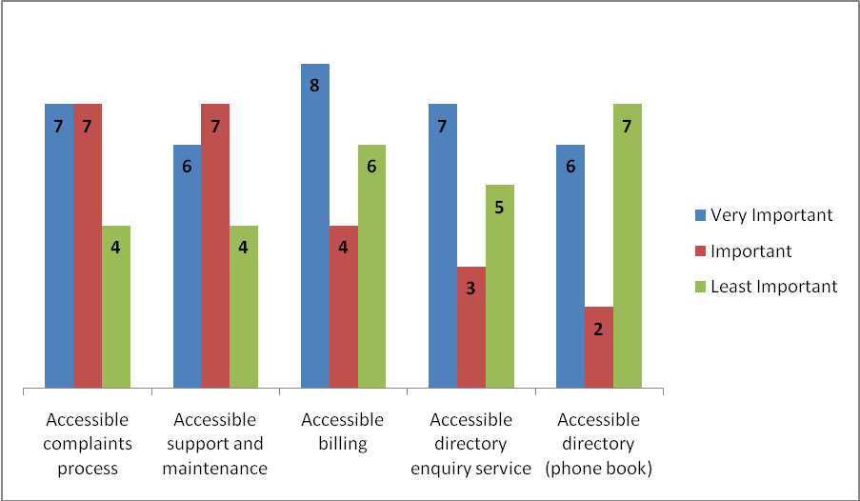

Complaint handling and support and maintenance

In the course of using any electronic communications service, issues may arise that require the customer to communicate with the service provider in order to get the issue resolved.

It is crucial that end-users with disabilities have access to the same support and maintenance service offered, if any, to other end-users. The key consideration here is that end-users with disabilities have a method of communication available which is appropriate to their disability. This may ultimately require that service providers offer, or on request, provide a range of communication methods with equivalent response and resolution times. It is also important that service providers make known what channels are available and how requests for other methods of communication can be made.

Billing

Electronic communications services bills can be complex and difficult for all end-users to understand. Of primary importance to end-users with disabilities is being able to access the bill in a form that is suitable to reasonably accommodate their particular access needs. It is common among MS for the USP to provide Braille, large print and audio bills for end-users who request these particular formats.

Many other providers may seek to move away from paper bills as standard and provide their customer bills in summary form and on-line as standard, which may not be the preferred method for every customer. In determining if access to billing is equivalent, the key point appears to be to determine if any of the formats offered can be accessed satisfactorily by the customer, given their particular disability, although this may not be their preferred method of access.

Example: Ireland – Quality Standard for Bill Presentation

The Irish Regulator, ComReg, has developed a quality standard for bill presentation aimed at improving the overall quality in terms of presentation of electronic communications bills for Irish end-users. One of the sections in the standard relates to accessibility, and there is a special standard achieved if the service provider meets the criteria in this section.

Directory Services

When contacting new people or organisations, most end-users use some sort of directory service to find out what number to call (printed directory, on-line directory, directory enquiry service). In this case, the on-line and printed directories allow end-users to get a number free of charge while there is generally a charge for a directory enquiry service. In assessing equivalent access, it is necessary to ascertain if end-users with disabilities have the ability to use the directory enquiry services free of charge. In many MS, under USO the USP provides a free directory enquiry service for end-users with disabilities, who have registered to use that service.

Example: Ireland – Access to Free Directory Enquiry Service for end-users with disabilities

In Ireland, more than 10 operators (fixed and mobile) provide, on a voluntary basis, a free directory enquiry service for their customers with disabilities, who have registered for the service. This initiative was agreed and implemented through ComReg’s Forum on electronic communication services for people with disabilities.

3.2 Assessing equivalent choice

Article 23a 1(b) states that disabled end-users should be able to benefit equivalent choice. When asked to list factors that they deemed are important in assessing equivalent choice, NRAs were of the view that there were two components comprising equivalent choice for end-users with disabilities:

- having a range of service providers that provide accessible services to choose from;
- being able to exercise their choice.

3.2.1. End-users with disabilities having a range of service providers that provide accessible services to choose from

NRAs were of the view that the availability of a range of service providers that provide accessible services is of high importance with respect to equivalent choice; this is illustrated in figure 4.

Figure 4: What is the most important factor with respect assessing to equivalent choice? – range of service providers with accessible services
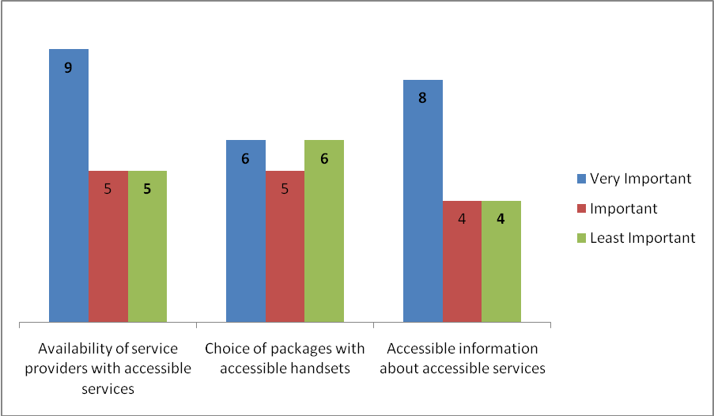

Range of service providers

Most NRAs considered that having a range of service providers with accessible services is the primary indicator with respect to equivalent choice. They were of the opinion that without a range of services which are accessible to end-users with disabilities there is not equivalent choice. In a competitive market, most end-users have a choice of service providers.

However, not all service providers will offer every service or package that particular customers want but in most cases, end-users have a choice of providers offering the particular services that they want. When assessing choice for end-users with disabilities a key factor is to ascertain if there are a number of service providers offering accessible services so that the majority of end-users with disabilities have a choice of service provider.

In assessing if services are accessible, the factors listed in section 3.1 should be considered. These are availability of accessible terminal equipment, price, the number of suppliers and additional set up, accessible complaint handling/support and maintenance, accessible billing and accessible directory services. One of the likely considerations, given that the range of service providers providing accessible services may not be as extensive as all service providers and offerings on the market, is whether the range of service providers with accessible services available is equivalent to all services/service providers available on the market.

Choice of packages with accessible handsets

One of the other factors also considered important is that where handsets are offered as part of the package for all end-users, there should be equivalent packages available with accessible handsets. This allows end-users with disabilities to benefit from deals available to other end-users, which include the subsidisation of handsets as part of the package price/subscription fee.

Another consideration rated important by NRAs is that handsets used by end-users with disabilities should be capable of being used on a variety of networks, if accessible handsets are not generally made available as part of the package price.

Accessible information regarding services provided

Many end-users find it hard to locate, understand and compare information with respect to the services provided by service providers. In the case of end-users with disabilities, this may be more challenging and without this information, end-users with disabilities cannot be assured of what service providers are providing accessible services. Article 21 (f) is supportive in this respect and facilitates the provision of information by undertakings on a regular basis to ‘inform disabled subscribers of details of products and services designed for them.
In addition to providing such information, it is important that it can be accessed by the end-users that need to refer to it, thus it should be made available in a number of accessible formats.

Example:– accessible terms and conditions

In Lithuania the providers, designated to provide universal services, together with bills shall, to a blind or partially sighted subscriber of universal services – in Braille and/or by telephone and to a deaf or hearing impaired subscriber of universal services – in writing present the updated information on the conditions for provision of universal services.

3.2.2. End-users with disabilities being able to exercise their choice

Having first examined whether a range of service providers exist with accessible services as outlined in 3.2.1, it is then necessary to assess whether end-users with disabilities can exercise their choice in terms of comparing offers and switching service provider in an equivalent way to other end-users. In this respect, most NRAs were of the view that having accessible information about prices and contract terms and an accessible switching procedure are important factors. Figure 5 depicts the factors that NRAs deem important for end-users with disabilities with respect to being able to exercise their choice.

Figure 5: What is the most important factor with respect assessing to equivalent choice? – being able to exercise choice
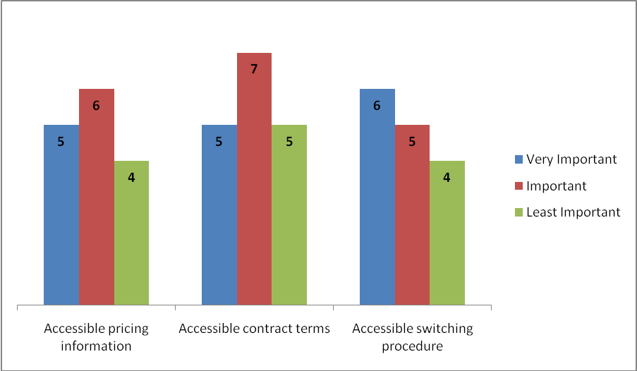

Accessible information about prices

In general, end-users may find it hard to compare packages and, in particular, prices. However, NRAs are of the preliminary view that where pricing information is provided by undertakings or other bodies to end-users that it should be also available to end-users with disabilities. Making pricing information available to end-users with disabilities allows comparison of offers to facilitate making a choice between them. Simplifying pricing information will benefit not only end-users with intellectual disabilities but also end-users in general.

Accessible contract terms

When choosing services, end-users need to be aware of what exactly is being offered and under what conditions. Contracts by their nature can be complex and technical and most end-users, as well as those with intellectual disabilities, will benefit from easy to read contract terms.

For end-users with other disabilities a key consideration is the availability of accessible formats available as standard so that end-users with disabilities don’t have to make contact with service providers in order to ‘shop around’ as is the case for other end-users.

Accessible switching procedure

In accordance with the BEREC report on switching 2010, when end-users have compared the various offers available and selected the best package for them, it is important that the switching process does not cause undue burden on the consumer.

This principle may be more challenging to achieve for end-users with disabilities, therefore a key consideration is whether there are accessible switching processes available for end-users with disabilities such that they can switch service provider without any extra burden or time delay when compared with other end-users. In general, the key components of switching, where consumer accessibility needs to be considered, is communicating with the relevant operator to initiate the switch and providing authorisation for the switch and in some cases contacting the old operator with respect to the current contract.

3.3 Encouraging availability of terminal equipment

Article 23a (2) states that ‘in order to be able to adopt and implement specific arrangements for disabled end-users, MS shall encourage the availability of terminal equipment offering the necessary services and functions’.

The BEREC questionnaire sought NRAs’ views in relation to whether or not they expected to be responsible for implementation of this measure and what the NRA considered appropriate ways of achieving the objectives of Article 23a(2), should it have responsibility to implement the provisions of this Article.

3.3.1 Responsibility for this provision

The majority of NRAs that responded to this question either stated that they were of the preliminary view that they would not have responsibility for encouraging the availability of terminal equipment (2) or that they did not know whether they would have responsibility for implementing this provision (10). This is because the details of transposition of Article 23a are not yet known. Only 3 NRAs stated that they were of the view that they would have some responsibility with respect to implementing this provision. A key concern for NRAs in relation to implementing this provision is the NRA’s ability and suitability to assist with identification and sourcing and supply of the relevant terminal equipment.

3.3.2 Appropriate ways of encouraging availability

Notwithstanding that, the majority of NRAs are unsure whether or not they would have responsibility for implementing this provision; NRAs were asked to comment on whether certain ways of achieving this would be appropriate for NRAs to implement. Figure 6 presents NRAs’ preliminary views in relation how they could assist in encouraging the availability of terminal equipment.

There is a large degree of variation in the preliminary views with respect to the most appropriate way NRAs could achieve this objective. Most NRAs who responded (9) were of the view that it would not be appropriate for NRAs to consider publishing information about the use of terminal equipment for end-users with disabilities.

However, 10 NRAs were of the preliminary view that it may be appropriate for them to encourage undertakings to provide accessible terminal equipment. Also appropriate, according to 9 NRAs, without prejudice to the independence of the NRA, would be to liaise with Government Bodies and Departments with respect to terminal equipment. In Greece and France, this process of liaison is already in place.

Figure 6: What would your NRA consider appropriate ways of encouraging the availability of terminal equipment . . . .?
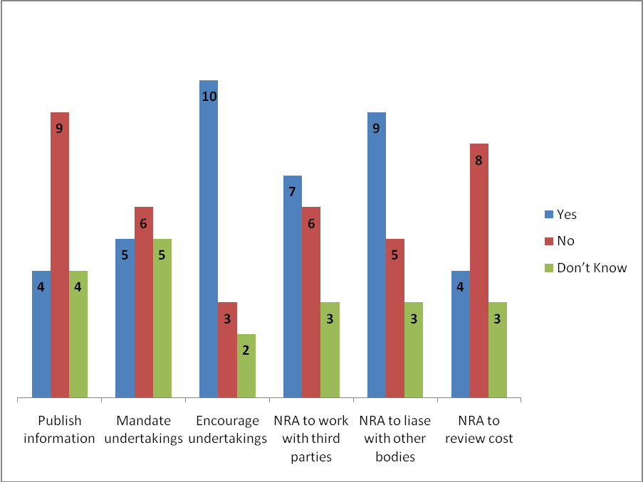

3.4 Assessing the needs of end-users with disabilities

NRAs were asked to comment with respect to complaints that they receive from end-users with disabilities in relation to access or choice of electronic communications services.

The responses indicate a low level of issues raised by end-users with disabilities to NRAs with respect to accessibility measures. This low level of issues reported may not be indicative of issues experienced by users with disabilities in relation to electronic communications. This may be because end-users with disabilities, for whatever reason, may not report issues with respect to access directly to NRAs. However, particular issues that have been raised include issues regarding terminal equipment, applicability of social tariffs and access to service providers’ premises.

Given the apparent lack of available information, in many MS, in relation equivalent access and choice of electronic communications for end-users with disabilities, NRAs will need to consider the best approach to collecting this information. In Ireland, ComReg has directly surveyed users with disabilities in April 2010 to establish some details regarding what the issues might be.

Also of note in this respect is the example in the Netherlands where the Ministry of Economic Affairs (Economische Zaken, EZ) conducted a research report (Toegang tot telecom), to prepare for national implementation of the, at that point, expected revised directive, published on 10th February 2010.

Consultation Question 2: Do you agree that the factors listed in sections 3.1.1 and 3.1.2 are important to consider when assessing equivalent access? Are there other factors which should be considered? Are some factors more important than others?

Consultation Question 3: Do you agree that the factors listed above (section 3.2.1 and 3.2.2) are important to consider when assessing equivalent choice? Are there other factors which should be considered? Are some factors more important than others?

Consultation Question 4: In your view, should the obligations currently in place under USO, for end-users with disabilities, be placed on all service providers? If no, what types of service providers, considering factors such as financial impact(cost), should the obligations be placed on? What is your view in relation to alternative mechanisms for funding?

Consultation Question 5: In what form should the information provided by service providers to inform end-users with disabilities of details of products and services designed for them and information regarding pricing and contracts be provided in?

Consultation Question 6: Do you consider it appropriate that NRAs have a role in encouraging the availability of terminal equipment, in accordance with Article 23 (a) (ii)? If yes, what do you consider that NRAs could do to achieve this?

4. Services and features available for end-users with disabilities

This section provides a high-level description of the measures that are in place, or which may be beneficial to be put in place, in MS, to achieve equivalent access and choice. Further details regarding measures reported in specific countries are contained in the section entitled ‘List of countries where services and features are reported as provided’

4.1 Services for users with disabilities: details of the services available or required

4.1.1 Services considered
A proposed list of services that may be considered relevant for end-users with disabilities was compiled. These services are listed below:

- SMS to speech  - Text relay service  - IP access to text relay service  - Video relay  - Video calling  - Special directory enquiry services  - Special directory (phone book)  - Accessible billing  - Information about accessible services and functions  - Accessible customer support | - Accessible user guides  - Set-up/configuration assistance for disabled end-users  - Special facilities for switching, including number porting (i.e. special contact methods and consent formats)  - Special measures for access to emergency services  - Special measures for repair services (e.g. fault reporting and priority)

NRAs were invited to indicate if these services are available for fixed telephony, mobile telephony and internet in each Member State.
There were additional services referred to by some MS responding to the questionnaire such as:
- Real Time Text (RTT) – Netherlands ⁽⁾;
- Telephone service with a pre-defined call receiver – Portugal.

4.1.2 Key findings
Text relay services, accessible billing, information about accessible services and functions and special measures for access to emergency services are the most common services available and provided according to respondent NRA’s ⁽⁾. The level of availability of these services reflects also on the importance given to them by the NRAs – indicating that they are considered as the most important measure in ensuring accessibility.
In contrast, special facilities for switching, accessible user guides and special measures for repair services seem to be the less available, although available in a number of MS. In general, mobile and fixed telephony appear to be the most common platforms where measures for end-users with disabilities are made available.
The USP is highlighted by many NRAs as a major provider of information about accessible services and functions, text relay services, special enquiry services, accessible billing and special measures for access to emergency services. Some of these services are among those which are available in the majority of the responding MS.
Text relay is provided by the USP in many MS, with rebates for text relay calls available in some countries.

Example: UK Text Relay service
The USP must establish and fund a text relay service. All communications providers are required to give their customers access to text relay, and they all currently do this by giving access to the service provided by the USP.

Free directory enquiries for end-users who cannot use a printed directory because of their disability (for example visually impaired end-users), are available in a number of MS.
Notwithstanding the above, the data collected leads us to the conclusion that in some cases undertakings other than the USP are also providing a number of services voluntarily. The responses also gave examples where these services are being provided by third party organisations, such as disability associations or government bodies.
Example:– service provided by third party organisations

Norway referred Video Relay Service as being provided the Norwegian Labour and Welfare Service (NAV) that also subsidises it for those at work, covering the costs of the equipment, while employers cover traffic costs.

4.2 Features for end-users with disabilities: details of features available/required

4.2.1 Features considered
A proposed list of features that may be considered relevant for end-users with disabilities was compiled. These features are listed below:

- Handsets with large keys and layout suitable for disabled end-users  - Hands free  - Acoustic coupler to facilitate hearing-aid compatibility  - Specialist headsets  - Voice output / read out messages  - Voice output menus / navigation | - Volume  - Text and picture size (zooming)  - Display screen contrast  - Voice dialling  - Backlit Keypad  - Flashing Indicator  - Vibrate Function  - Voice dialling  - Quick dial/speed dial keys

NRAs were invited to indicate whether these functions are available for fixed and mobile telephony, as well as for internet telephony and browsing, as appropriate. NRAs were also invited to provide information on two specific features of internet browsing: facilities to allow web pages to be read out loud and compliance of web sites with accessibility standards for example the Web Accessibility Initiative (WAI). WAI develops strategies, guidelines and resources to help make the web accessible to people with disabilities.

4.2.2 Key findings
Handsets with large keys for fixed telephony, quick dial and speed dial keys for mobile telephony, volume adjustment for mobile telephony and vibrate function for mobile telephony appear to be the most common features available within responding MS.
In contrast, voice output menus or navigation for fixed telephony, hands free for internet telephony, voice output or read out messages for internet telephony and vibrate function for internet telephony appear to be less widely available.
Some NRAs emphasised that several features, as listed above, are readily available on some handsets and that it is difficult to ascertain their cost separate to the cost of the handset. Also, Switzerland noted that it was not aware of any particular regulation with respect to terminal equipment for end-users with disabilities.
All listed features can, to some degree, facilitate access for end-users with disabilities (which makes it difficult to assess them independently of the type or scope of the disability) however a number of NRAs indicated that some specific features were more particularly useful – for instance, features such as text and picture size on internet browsing, flashing indicator on fixed telephony and handsets with large keys on fixed telephony.
The USP is indicated to be the primary provider in fixed telephony of handsets with large keys, quick dial and speed dial keys and volume. These three features are widely available in the majority of the responding countries.
Notwithstanding the above, once again, the data collected suggests that undertakings other than the USP are also providing quite a number of features voluntarily. Responses also show examples where these features are being provided by third party organisations, such as disability associations or government bodies.

Example: Switzerland – features provided by third party organisations

Switzerland stated that the federal administration offices and public services companies influenced by the government are required to offer disability friendly services, such as accessible ticket machines, accessible transport systems, internet access according to W3C standards, also allowing audio and Braille displays/keyboard at reception.

The majority of the features included in the survey are provided by administration organizations sites (including work places and public services controlled by the administration), although in several cases they are widely available on the market and in some cases they may be included in the support packages offered for end-users with disabilities.

4.3 Payphones: details of the measures for access to payphones and services from payphones for end-users with disabilities

4.3.1 Features considered
A group of measures for access to payphones, as well as services from payphones for users with disabilities were mentioned by NRAs as follows:

- Special measures to ensure physical access to payphones;  - Handsets with large keys and layout suitable for end-users with disabilities;  - Hands free;  - Acoustic coupler to facilitate hearing-aid compatibility;  - Specialist headsets  - Voice output | - Volume;  - Text size;  - Display screen contrast;  - Voice dialling;  - Quick dial /speed dial keys;  - Backlit keypad;  - Flashing indicator;  - Braille notation on payphones keypads;  - Relay service

The Greek NRA also mentioned the availability of teletypewriters payphones when requested, by end-users with disabilities, which enable people who are deaf or have a communication impairment to stay in touch when out and about.

4.3.2 Key findings
While providing details of measures for access to payphones and services from payphones for end-users with disabilities, a number of MS (Sweden, Switzerland, UK, Ireland) drew attention to the fact that in general, payphones are currently being less used in some countries than they were in the past.
Attention was also drawn to the importance of competent bodies conducting an impact analysis prior to mandating the provision of specific features to be available at payphones. In this respect, it is important to evaluate and compare between costs of fully featured payphones and the benefits of their availability as well as their usage by end-users that require them.
It is foreseeable that in a situation where costs are much higher than the expected benefits, national bodies could decide not to mandate the provision of specific features at payphones. Service providers could also refrain from voluntarily making available many of the features identified and limit the provision of features to fundamental measures, such as to ensure physical access to payphones, namely for people using wheelchairs, adequate volume levels or acoustic coupler to facilitate hearing-aid compatibility. Many of these features are already commonly available at payphone locations and provided by the USP on a mandatory basis, based on information collected from NRAs.
The remaining measures listed above regarding access to payphones are provided voluntarily in most of the responding MS, either by the USP, or by other undertakings.
4.4 Availability of accessible terminal equipment

4.4.1 Availability of mobile handsets

Mobile handsets sold as suitable for people with visual impairments

Mobile handsets sold as suitable for people with visual impairments are available in a number of MS. Unlike with fixed handsets, we did not find any examples of accessible mobile handsets being provided by the designated USP. However, in some MS they are provided voluntarily by communications providers other than the USP. There are also examples of such handsets being provided by third parties such as charities, and being sold by private sector suppliers.

Mobile handsets sold as suitable for people with hearing impairments

Mobile handsets sold as suitable for people with hearing impairments appear to be more widely available than handsets suitable for end-users with other disabilities, and they are more likely to be provided by the communications providers rather than end-users having to go to third party providers.

Mobile handsets sold as suitable for people with dexterity problems

Again, mobile handsets sold as suitable for people with dexterity problems are available in some MS. As with handsets for visually impaired people, there are examples of them being provided by third parties such as charities, and being sold by private sector suppliers.

Mobile handsets sold as suitable for people with cognitive impairments

Mobile handsets sold as suitable for people with cognitive impairments are much less widely available than handsets sold as suitable for people with other impairments. Overall, there appears to be more provision for people with visual and hearing impairments than for people with dexterity problems or cognitive impairments.

4.4.2 Availability of fixed line handsets

Fixed line handsets sold as suitable for people with visual impairments

Fixed line handsets sold as suitable for people with visual impairments are available in a number of MS. In a small number of MS, the USP is required to provide accessible fixed line handsets suitable for people with visual impairments to disabled end-users.

Fixed line handsets sold as suitable for people with hearing impairments

Fixed line handsets sold as suitable for people with hearing impairments are available in a number of MS, and in a small number of MS, the USP is required to provide them.

Fixed line handsets sold as suitable for people with dexterity issues

Fixed line handsets sold as suitable for people with dexterity issues are available in some countries, but as with mobile handsets, there appears to be less provision for people with dexterity problems and cognitive impairments than for end-users with visual or hearing impairments.

Fixed line handsets sold as suitable for people with cognitive impairments

Fixed line handsets sold as suitable for people with cognitive impairments are available in a small number of MS.

4.4.3 Availability of terminal equipment for Internet usage

Internet (VoIP) phones sold as suitable for disabled people

Internet (VOIP) phones sold as suitable for disabled people are clearly in their infancy, with only a couple of MS reporting that they were available.

Specialist screens and keyboards for disabled people

Specialist screens and keyboards for disabled people are available in a number of MS.

Consultation Question 7: In addition to the services, features and types of terminal equipment listed are there any others which you consider necessary to ensure equivalent access?

Consultation Question 8: Where services, features or terminal equipment suitable for end-users with disabilities have been provided voluntarily, has there been encouragement from NRAs Government or other parties, or does it appear that the market is delivering and will continue to deliver of its own accord?

Consultation Question 9: What consideration should be given to NRAs mandating undertakings to provide services, features or terminal equipment for end-users with disabilities as part of the standard services and packages they offer?

Consultation Question 10: What is the role for public procurement of accessible terminal equipment, as it is likely that NRAs may have no powers with respect to design or supply?

4.5 Funding and provision of subsidies for services for disabled end-users
There are many examples where MS subsidise, to varying degrees, the features, services and terminal equipment in place for end-users with disabilities.
Examples: subsidies for services required for users with disabilities

While responding to the questionnaire, Norway stated a significant number of services as being subsidised by The Norwegian Labour and Welfare Service (NAV).

Sweden indicated that the NRA procures important communication services for users with disabilities. These services include text relay, video relay services and special directory services. Equipment needed for use in the workplace may be subsidised by the Swedish Public Employment Office and terminal equipment for personal use is provided by County Councils at varying prices for disabled end-users. County Councils are assemblies of Swedish Counties considered political entities, elected by the counties electorates, which main responsibilities lie within the public health care system.

Examples: funding for mobile handsets for disabled end-users

State funding for personal use:
In Lithuania, state funds are used to subsidise two-thirds of the price of a new handset every six years.

State funding for workplace use:
In Sweden, the Swedish Public Employment Office subsidises equipment needed by end-users with disabilities in the workplace. State funding of end-use equipment for users with disabilities is reported at €3 million/year in Sweden.

Funding from healthcare insurance:
In The Netherlands, accessible handsets are subsidised through healthcare insurance.

Examples: funding of fixed line handsets for disabled customers

Subsidy from the USP:
In the Czech Republic, the USP is required to lease or sell adapted fixed line electronic communications terminal equipment to disabled people at the same price as standard electronic communications equipment. The NRA has set the price, including VAT, at 29 CZK (approx €1.14) per month if leased or 459 CZK (approx €18) if purchased.

Subsidy on a voluntary basis:

In Portugal, end-users are offered to pay €30.90, with the remainder subsidised by the provider. This is only applicable to hearing impairments; This is not offered by all providers, instead relates to a USP offer provided on a voluntary basis; This offer is made available through a Foundation created by the USP that develops research to meet disabled end-users’ needs.

State funding for personal use:
In Lithuania, the state budget covers the first 300 litas (approx €85) of the cost of a new handset every six years.

State funding for workplace use:
In Sweden, special equipment needed by users with disabilities in the workplace is subsidised by the Swedish Public Employment Office.
Example:– features provided by third party organisations

While responding to the questionnaire, Norway stated a significant number of features are being subsidized by The Norwegian Labour and Welfare Service (NAV).

Sweden indicated that, while the NRA procures important communication services for users with disabilities, terminal equipment is provided by County Councils at varying prices for disabled end-users. County Councils are assemblies of Swedish Counties considered political entities, elected by the counties electorates, which main responsibilities lie within the public health care system.

Switzerland, Ireland and the UK, in some cases, reported to have successful subsidy schemes for specific features and services required for end-users with disabilities.

For example, In Ireland the designated USP offers a rebate scheme for users registered with a hearing impairment when making text telephone calls. As these calls take longer to make and, to ensure equality of payment, the USP offers a % rebate for registered users who make text telephone calls.

In Switzerland, the Federal Bureau for Equality of people with Disabilities surveys and suggests changes to the legislation across a range of sectors. This may also include the financing of equipment and services with a view to maximising the effect on society.

State funding of video relay for workplace and personal use is in place in Sweden. In a small number of MS, video relay is funded for workplace use only, and in some other MS, there are commercial video relay services.

Case Studies mixed funding model for video relay

In Germany, workplace and private use are organised separately, but both rely on grants awarded to deaf people by the integration agency. Workplace video relay is provided by TeleSign on a commercial basis: €154/month for up to 20 minutes/month, €307 for 20-100 minutes/month, then €1.50 for every additional minute (all + 19% sales tax). Domestic use is provided by Tess (http://www.tess-relay-dienste.de). End-users pay a €5/month and then €0.14/minute for text relay and €0.28/minute for video relay. The remainder of the cost is met by the communications providers, who pay into a fund.

In Sweden, the video relay service for end-users with disabilities is procured by the Swedish NRA and it is available for both personal and workplace use.

Social tariffs for end-users with disabilities exist in several MS. These are almost all provided by USPs. Preferential SMS-only tariffs for hearing-impaired people were reported as being available in a small number of MS.

Consultation Question 11: Where a subsidy is available for services, features or terminal equipment needed for disabled end-users is the up-take as expected and are there any barriers to take-up? If yes, what are the barriers?

Consultation Question 12: If funding is provided to facilitate equivalent access for disabled people, is it best targeted at purchase of equipment, discounts on tariffs, by subsidising special services such as relay services or by direct payment to the user?

Consultation Question 13: Are there any details available on the cost per user of implementing any of the measures mentioned in the report?

5. Proposed approach to achieve equivalent access and choice

At this preliminary stage, BEREC proposes that it may be appropriate for NRAs to consider the following steps in considering what measures, if any should be implemented in respect of Article 23a(1).

- Determination of factors to assess equivalent access & choice;
- Assess each factor for end-users with disabilities and other end-users;
- Identify proportionate measures to address issues with respect to equivalence;
- Consult with interest parties regarding proposed measures and obligations on undertakings.
5.1 Determination of factors to assess equivalent access and choice
It is proposed that NRAs, referencing Section 3 of this report, should determine what factors are important in the context of their MS in relation to equal access and equal choice for end-users with disabilities, for the electronic communications services available in that MS (fixed phone, mobile, internet).

Factors proposed in Section 3 to be examined with a view to ensuring equal access include:-

- Availability of accessible terminal equipment (depending on the role of NRA with respect to terminal equipment);
- Price;
- Number of additional suppliers and additional setup;
- Accessible complaint handling and support and maintenance processes;
- Accessible billing;
- Accessible directory services.

Factors proposed in Section 3 to be examined with a view to ensuring equal choice
include:-
- Range of services and service providers with accessible services;
- Choice of packages with accessible handsets (depending on the role of NRA with respect to terminal equipment);
- Accessible information regarding the services provided;
- Accessible information about prices;
- Accessible contract terms;
- Accessible switching procedure.

5.2 Assess each factor for end-users with disabilities in relation to other end-users

To assess equivalence in relation to other users, it seems imperative that NRAs gather information regarding the practical situation of disabled end-users vis-à-vis access and choice of electronic communication services in order to provide a coherent and comprehensive answer to their needs.

Article 23a provides for access and choice for end-users with disabilities equivalent to that enjoyed by the majority of end-users. In this respect, it is also important for NRAs to gather information regarding access to and choice of services with respect to ‘the majority of users’ so that comparisons can be made.

Therefore, for each of the factors deemed necessary, to assure equivalent access and choice, in accordance with 5.1 above are established, it is proposed that NRAs would undertake an exercise to examine the current status of these facilities in the MS. This will allow the NRA to identify potential gaps in equivalence in access and choice and to get an understanding of the extent of such gaps.

Example: Netherlands – research report

In Netherlands, The Ministry of Economic Affairs (EZ) conducted a research report to prepare for national implementation of the, at that point, expected revised directive, published on 10th February 2010. Interviews with stakeholders were an important source of information for the report. The analysis of the needs and problems of people with disabilities was largely based on interviews. The analysis of technological trends in the electronic communications sector was also primarily based on interviews.

To obtain an insight into potential measures, policy considerations and experiences in five other EU countries have also been examined: Belgium, France, Germany, Sweden and United Kingdom.

In addition to US services (fixed telephony, telephone directory, subscriber information service), the study also looked at mobile telephony, the internet and accessibility of emergency services.

The analysis of the needs and problems of the various groups initially examined single disabilities that may cause difficulties in terms of telecommunication (visual, auditory, cognitive and motor), but the report analysed the difficulties experienced by people with a combination of disabilities, too. The report contains also a set of conclusions and recommendations.

5.3 Identify proportionate measures to address issues with respect to equivalence

In accordance with Article 8 of the Framework Directive (2009/140/EC), the measures aimed at achieving the objectives should be proportionate to those objectives. Therefore, a cost benefit analysis examining the cost, applicability and benefit of the measures proposed should be undertaken to evaluate, assess and refine the measures proposed.

It is proposed that a review of the current legal framework and the actual conditions applied in each MS with respect to end-users with disabilities in relation to electronic communications would provide important input in assessing any potential new obligations to be imposed on undertakings under Article 23a.

In reviewing the actual conditions, and proposing new measures for disabled en-users, one important aspect is whether or not there are comparable measures in place for other end-users. If this is not the case, specific measures in relation to disabled end-users may need to be specifically justified in term of proportionality.

Another area for consideration relates to the benefit derived from the proposed measures which should include not only the number of disabled end-users who might potentially benefit from the proposed measures but also reflect the practice and experience of disabled end-users in relation to existing services. For example, one Member States actually experiences that only a few disabled end-users are actively using a special accessibility service that addresses a great number of disabled end-users and incurs enormous costs a year. With regard to such situations, in practice the realisation of any choice of services and providers is limited. The obligation to double such non cost profitable services or structures to ensure a choice of services has to be avoided.

Based on the current legal framework in each Member State, three main scenarios with respect to the role of Article 23a can be identified:

- Where the NRA identifies a lack of legal provisions or other means to address the specific access or choice needs of end-users with disabilities that are not satisfied by the market on voluntary basis, Article 23a could provide the legal basis for new provisions, applicable to all providers of electronic communication services;

- In some cases, measures already exist that extend beyond the USO. Where necessary, those measures could be strengthened by means of the new legislative framework. For example, NRAs could extend the scope of the existing measures (which may be in place on a voluntary basis) by making them legal obligations or extending their scope or applicability;

- Where the market adequately addresses the needs of end-users with disabilities and the current provisions in place are sufficient to enable access and choice of electronic communications services for users with disabilities, NRAs may wish to monitor the situation, set a common approach across the entire sector, or continue the work of mediation between service providers and organisations representing end-users with disabilities. The new legal framework could facilitate these tasks by enabling NRAs to have enhanced decisional powers where voluntary initiatives such as the introducing codes of practice or dialogue with interested stakeholders fails to progress or to achieve the required objective.

Where gaps in equivalence have been identified (5.2), with reference Section 3 and Section 4 of this report, it is proposed that NRAs would evaluate options to achieving equivalent access and choice for end-users. It is understood that in some cases where NRA does not have responsibility for implementing Article 23a(2) – encouraging the availability of terminal equipments – measures in relation to this may not be evaluated.

5.4 Consult with interest parties regarding proposed measures and obligations on undertakings;
Article 33 ⁽⁾ of the 2009 Directive, which relates to the consultation by NRAs with interested parties including consumers, end-users with disabilities, is important in this context. The implementation of Article 33 provides a specific legal obligation to ensure that the process of decision making in relation to end-user and consumer rights includes due consideration of consumer interests in relation to electronic communications.

It is proposed, in line with regulatory procedure, that NRAs would consult on the measures proposed under article 23a. In this case, it is most important that the consultation process should aim to ensure that inputs from all stakeholders including those with disabilities can be obtained and therefore the consultation documents and process should be fully accessible.

Consultation Question 14: Are you in agreement that the steps, as proposed above, are appropriate for NRAs to consider when preparing to implement Article 23a? Are there any additional factors that should be considered?
Consultation questions

Consultation Question 1: Are there additional legal provisions, other than those listed in Section 2, currently in place in MS with respect to end-users with disabilities regarding electronic communications? If yes, please detail the provisions and the organisation responsible for implementing or monitoring these provisions.

Consultation Question 2: Do you agree that the factors listed in sections 3.1.1 and 3.1.2 are important to consider when assessing equivalent access? Are there other factors which should be considered? Are some factors more important than others?

Consultation Question 3: Do you agree that the factors listed above (section 3.2.1 and 3.2.2) are important to consider when assessing equivalent choice? Are there other factors which should be considered? Are some factors more important than others?

Consultation Question 4: In your view, should the obligations currently in place under USO, for end-users with disabilities, be placed on all service providers? If no, what types of service providers, considering factors such as financial impact(cost), should the obligations be placed on? What is your view in relation to alternative mechanisms for funding

Consultation Question 5: In what form should the information provided by service providers to inform end-users with disabilities of details of products and services designed for them and information regarding pricing and contracts be provided in?

Consultation Question 6: Do you consider it appropriate that NRAs have a role in encouraging the availability of terminal equipment, in accordance with Article 23 (a) (ii)? If yes, what do you consider that NRAs could do to achieve this?

Consultation Question 7: In addition to the services, features and types of terminal equipment listed are there any others which you consider necessary to ensure equivalent access.

Consultation Question 8: Where services, features or terminal equipment suitable for end-users with disabilities have been provided voluntarily, has there been encouragement from NRAs Government or other parties, or does it appear that the market is delivering and will continue to deliver of its own accord?

Consultation Question 9: What consideration should be given to NRAs mandating undertakings to provide services, features or terminal equipment for end-users with disabilities as part of the standard services and packages they offer?

Consultation Question 10: What is the role for public procurement of accessible terminal equipment, as it is likely that NRAs may have no powers with respect to design or supply?

Consultation Question 11: Where a subsidy is available for services, features or terminal equipment needed for disabled end-users is the up-take as expected and are there any barriers to take-up? If yes, what are the barriers?

Consultation Question 12: If funding is provided to facilitate equivalent access for disabled people, is it best targeted at purchase of equipment, discounts on tariffs, by subsidising special services such as relay services or by direct payment to the user?

Consultation Question 13: Are there any details available on the cost per user of implementing any of the measures mentioned in the report?

Consultation Question 14: Are you in agreement that the steps, as proposed above, are appropriate for NRAs to consider when preparing to implement Article 23a? Are there any additional factors that should be considered?

List of countries where services and features are reported as provided (Section 4)

Note: The measures are listed in this section in accordance with measures reported by NRAs; it is not an exhaustive list.

Text Relay Services - Czech Republic, Germany, Greece, Hungary, Ireland, Italy, Latvia, Netherlands, Norway, Portugal, Slovakia, Sweden, Switzerland, UK.

Video Relay Service - Germany

Accessible billing - Czech Republic, France, Greece, Ireland, Italy, Lithuania, Netherlands, Norway, Poland, Portugal, Slovenia, Sweden, Switzerland, UK.

Information about accessible services - Czech Republic, France, Greece, Ireland, Italy, Lithuania, Malta, Norway, Portugal, Slovakia, Slovenia, Sweden, Switzerland, UK.

Functions and special measures for access to emergency services - Czech Republic, France, Greece, Ireland, Italy, Malta, Netherlands, Norway, Portugal, Romania, Slovakia, Slovenia, Sweden, Switzerland, UK.

USP as the main provider of information about accessible services and functions - Czech Republic, Greece, Ireland, Italy, Latvia, Malta, Norway, Portugal, Slovakia, Slovenia, Switzerland, UK.

USP as the main provider of text relay services - Czech Republic, Greece, Ireland, Italy, Netherlands, Norway, Portugal, Slovakia, Switzerland, UK.

USP as the main provider of special enquiry services - Czech Republic, France, Ireland, Italy, Latvia, Netherlands, Norway, Portugal, Slovenia, Switzerland, UK.

USP as the main provider of accessible billing - Czech Republic, Greece, Ireland, Italy, Latvia, Norway, Poland, Portugal, Slovenia, UK.

Handsets with large keys for fixed telephony - Czech Republic, France, Germany, Greece, Hungary, Ireland, Italy, Lithuania, Malta, Netherlands, Norway, Poland, Portugal, Romania, Slovakia, Sweden, Switzerland, UK.

Quick dial and speed dial keys for mobile telephony - Czech Republic, France, Germany, Greece, Hungary, Ireland, Italy, Lithuania, Malta, Netherlands, Norway, Poland, Portugal, Romania, Slovakia, Sweden, Switzerland, UK.

Volume adjustment for mobile telephony - Czech Republic, France, Germany, Greece, Hungary, Ireland, Italy, Lithuania, Malta, Netherlands, Norway, Poland, Portugal, Romania, Slovakia, Switzerland, UK.

Vibrate function for mobile telephony - Czech Republic, France, Germany, Greece, Hungary, Ireland, Italy, Lithuania, Malta, Netherlands, Norway, Poland, Portugal, Romania, Slovakia, Sweden, Switzerland, UK.

The USP as the predominant provider of handsets with accessible features for fixed telephony - Czech Republic, Greece, Hungary, Ireland, Malta, Poland, Portugal, Slovakia, Switzerland, UK.

Glossary of terms

Given the technical nature of some of these issues, we have provided a glossary of English terms and phrases used in this report to describe different topics relating to the accessibility of electronic communications:

Backlit keypad: Some mobile phones have keypads that light up, making it easier to see the numbers and letters in the dark.

BEREC: Body of European Regulators for Electronic Communications

Billing: electronic or paper bills made available to end-users

Consumer: any natural person who uses or requests a publicly available electronic communications service for purposes which are outside his or her trade, business or profession (the definition provided by the EU Framework Directive).
Display screen contrast: The screen on some phones uses a display with more or better contrast than others.

Electronic communications service - This is a service normally provided for remuneration which consists of wholly or mainly in the conveyance of signals on electronic communications networks, including telecommunications services and transmission services in networks used for broadcasting, but exclude services providing or exercising editorial control over content.(the definition provided by the EU Framework Directive)

End-User: means a user not providing public communications networks or publicly available electronic communications services.

Flashing indicator: Phones may offer a flashing display function, which visually notifies you of an incoming call or text message.

Hands-free: A phone that you can use hands-free, by having an in-built microphone and loudspeaker, can be useful if you have trouble holding a handset.

Headsets: Some phones can be used with an earpiece or headset. This may be connected either through a standard ‘mini jack’ headphone socket in your phone or wirelessly using Bluetooth.
Bluetooth is the name of the technology that allows devices to communicate wirelessly. This can produce better call quality for some people and is easier to use if you need voice output.

Hearing-aid compatible: Phones that can be used with a hearing aid (hearing-aid compatible phones) can be much easier to use if you are hard of hearing. To use this feature, set your hearing aid to the ‘T’ position.

Large keys: Some phones have keys that are larger than normal, well spaced or recessed and with a raised dot on the number 5. These can be much easier to use for people who have difficulty seeing or operating small controls.

Quick dial keys: Many phones allow you to associate specific numbers to certain keys, so that pressing the key automatically dials the number. In some cases, special keys are provided with symbols on them to indicate the function, such as Doctor, Police or Assistance. This can be very useful in providing security if you cannot easily remember numbers.
SMS to speech: This is a service that converts any text messages (also called SMS) that are sent to you into speech so you can listen to them. This can be very useful if you have difficulty reading the display and do not have a phone that can convert text to speech itself.

Switching: a transfer of services between service providers whereby the new service provider facilitates the transfer on behalf of the consumer.

Text (SMS) and multimedia messaging (MMS): All mobile phones and some fixed-line phones can be used to send text messages. Some can also send multimedia messages that contain video, sound, or photographs.

Text relay service: This service allows you to receive voice messages on a text-phone by translating them into text. You can then send that text to the text-phone of customers of any operator.
Text size: Some phones have larger displays with bigger text or text that is adjustable in size if you have low vision.

Universal Service Obligation (USO) - A specific requirement placed on an operator(s) which has been designated to provide certain services to all specified persons

Universal Service (US) - The provision of a defined set of services to all end-users regardless of their geographical location and, in light of specific national conditions, at an affordable price. It is a basic level of telecommunications services, having a legal basis, which should be available to all customers.
Universal Service Provider (USP) An operator that has been designated to comply with specific obligations designed to ensure that a basic level of telephony service is available to everyone in the licensed area upon request.

Vibration Function: A phone with a built in vibration function will notify you of an incoming call or text message by vibration.

Video calling: This enables communication between two handsets using live video. Currently, this service is available only on mobile handsets which are equipped to access the 3Gnetwork (3G stands for ‘Third Generation’ and enables you to use services such as the Internet, or Instant Messaging on your 3G enabled mobile phone).

Voice dialling: This allows you to dial a person by just speaking their name, once you have entered their number into the phone’s ‘phone book’.

Voice output: Voice output is available on some mobile phones to speak out the menus and other information on the display. Voice output makes most or all of the phone’s functions available if you cannot read the text on the display.

VoIP (Voice over Internet Protocol) - The generic name for the transport of voice traffic using Internet Protocol (IP) technology. The VoIP traffic can be carried on a private managed network or the public Internet (see Internet telephony) or a combination of both. Some organisations use the term 'IP telephony' interchangeably with 'VoIP'
Volume: Some phones are louder than others. Most have adjustable volume level.

References

BoR (10) 34 - Draft BEREC Report on Best practices to facilitate switching
http://www.erg.eu.int/doc/consult/bor_10_34_switching.pdf

BoR (10) 35 - BEREC Report on Universal Service – reflections for the future
http://www.irg.eu/streaming/BoR%20(10)%2035%20BEREC%20Report%20on%20USO_final.pdf?contentId=546910&field=ATTACHED_FILE
ComReg 2010 – ComReg Disability Survey – September 2010

http://cms.horus.be/files/99909/MediaArchive/Com%282005%29425_EC%20Com_e-accessibility.pdf

EC (2007) – ‘The need for reform’ - European Commission, Information Society and Media, November 2007

EDF 2010 - European Disability Forum
http://www.edf-feph.org/Page_Generale.asp?DocID=12534

2002 USD - Directive 2002/22/EC of the European Parliament and the Council of 7 March 2002 on universal service and users’ rights relating to electronic communications networks and services (Universal Service Directive)

DIRECTIVE 2009/136/EC OF THE EUROPEAN PARLIAMENT AND OF THE COUNCIL of 25 November 2009 amending Directive 2002/22/EC on universal service and users’ rights relating to electronic communications networks and services, Directive 2002/58/EC concerning the processing of personal data and the protection of privacy in the electronic communications sector and Regulation (EC) No 2006/2004 on cooperation between national authorities responsible for the enforcement of consumer protection laws.

EC COM(2005)425 final - COMMUNICATION FROM THE COMMISSION TO THE COUNCIL,THE EUROPEAN PARLIAMENT AND THE EUROPEAN ECONOMIC AND SOCIAL COMMITTEE AND THE COMITTEE OF THE REGIONS - e- Accessibility
http://cms.horus.be/files/99909/MediaArchive/Com%282005%29425_EC%20Com_e-accessibility.pdf

Web Accessibility Initiative (WAI)
http://www.w3.org/WAI/
Toegang tot telecom, Ministry of Economic Affairs, 2010

http://www.ivir.nl/publicaties/vaneijk/toegang_tot_telecom.pdf

⁽?⁾ Belgium, Czech Republic, Finland, France, Germany, Greece, Hungary, Ireland, Italy, Latvia, Lithuania, Malta, Netherlands, Norway, Poland, Portugal, Romania, Slovakia, Slovenia, Spain, Sweden, Switzerland, UK.
http://www.irg.eu/streaming/BoR%20(10)%2035%20BEREC%20Report%20on%20USO_final.pdf?contentId=546910&field=ATTACHED_FILE
⁽?⁾ Belgium, Czech Republic, France, Greece, Ireland, Lithuania, Poland, Romania, Slovakia, Slovenia, Sweden, UK
Design for All - http://ec.europa.eu/information_society/activities/einclusion/policy/accessibility/dfa/index_en.htm
⁽?⁾ Belgium, France, Germany, Greece, Ireland, Italy, Lithuania, Poland, Romania, Slovenia, UK
⁽?⁾ Real-Time Text is conversational text that is sent and received on a character-by-character basis. The characters are sent immediately (in a fraction of a second) once typed and also displayed immediately to the receiving person(s). This allows text to be used in the same conversational mode as voice. Real-Time Text is of particular importance for people who are deaf or hard of hearing as a replacement for voice telephony.
⁽?⁾ Refer to list of countries where services and features are reported as provided
⁽?⁾ According to Article 33 of the amended Directive, “Member States shall ensure as far as appropriate that national regulatory authorities take account of the views of end-users, and consumers (including, in particular, disabled users), manufacturers, undertakings that provide electronic communications networks and/or services on issues related to all end-user and consumer rights concerning publicly available electronic communications services, in particular where they have a significant impact on the market”.

