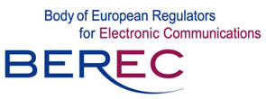
BEREC's Public Hearing

BEREC's Public Hearing

on Draft BEREC Work Programme 2012

Location, date and timing:

Permanent Representation of the Republic of Latvia to the EU
Avenue des Arts 23
B-1000 Brussels, Belgium

21 October 2011, from 10h30 to 12h00

Registration Form

To be filled in and returned by 17 October 2011 to e-mail:

BEREC@ec.europa.eu

Please fill in one form per participant
Title (Mr/Ms): | Family name: |  | First name:
Position:
Company:
Address:
Postcode + City:
Country:
Phone: |  | Fax:
Email: |  | Mobile:

Special requirements for admission to the venue:
The participants should show a valid ID document to the security guard in order to be admitted to the venue!

For additional information:
BEREC Office
Z. A. Meierovica Bulvaris № 14, 2nd floor
LV-1050 Riga, LATVIA
Tel. +371 6611 7590
http://berec.europa.eu/

