 | European  Cable  Communications  Association | 4 April 2005  ECCA 4671

Dear Mr Otruba,

Regarding: ECCA submission on the addition of a cable network access chapter to the Common Position on wholesale bitstream access

The European Cable Communications Association (ECCA) is the European trade association of cable operators and their national associations active in Europe. The main goal of the Association is to foster co-operation between cable operators and to promote and represent their interests at European and international level. ECCA members have between them more than 55 million subscribers.

As you may appreciate the ERG consultation on ‘wholesale broadband access via cable’ is of great interest to ECCA members. Whilst we appreciate the need to update NRAs understanding of technology issues related to broadband market definition, we would like to express our concern as to the timeliness and relevance of reviewing the notion of bit-stream access in such a technology specific manner.

The EU recommendation on relevant markets finds that HFC cable networks can only be included in ‘Market 12’ if they are shown to offer an equivalent service to that of bit-stream access over the twisted copper-based network. Therefore, we question the need to modify the original ERG bit-stream access document. As an initial observation, we note that much of consultation document does not deal with the specifics of the issue and instead focuses on some of the broader possibilities of cable networks providing a third party wholesale access offer. Whilst we do accept that wholesale access over cable is possible, however, that does not mean that such access is equivalent to bit-stream.

More specifically ECCA and its members have commissioned a report to examine the technical feasibility of whether cable networks can provide an equivalent offer to that of bit-stream from a network management, technical and commercial perspective. Its conclusion is that, for technical and commercial reasons it is unrealistic for cable networks to provide an equivalent service to that of PSTN bit-stream.

In particular, the report stresses:

- An “equivalent” offer via a cable network compared to wholesale bit-stream access via the PSTN is not likely to be possible from a technical perspective in current form

- 3rd party access via a dedicated CMTS is wasteful of bandwidth given the shared capacity nature of HFC cable networks

- For cable network operators third party wholesale access in general is technically difficult to achieve and would involve considerable, unplanned investment in network infrastructure

- There is little demand for bit-stream access to HFC cable networks given the absence of a national footprint, an uneven basis for standardization of bit-stream access to HFC cable networks and the desire of bit-stream access users to obtain a national footprint.

More generally, ECCA members observe that any kind of wholesale bit-stream access offer via cable networks is undesirable from an economic point of view. Firstly, from the perspective of potential wholesale partners implementation costs, imply that such a service would cost more than (existing) wholesale access offers via PSTN. Secondly, the burden of implementing a wholesale access offer will impact on the cable industry’s ability to compete with the incumbent telecoms operators.

We would also like to point out that the reference in the consultation document to NTL – page 17 – is incorrect. NTL does not offer wholesale bit-stream access to third parties. The service NTL is offering does not allow other operators to either manage or self-provide broadband conveyance and the agreements should be qualified as resale.

Wholesale access to cable is unlikely to stimulate broadband take-up.

When one looks at the European broadband access market today it is clear broadband cable plays a secondary role compared to DSL retail offerings. More importantly, the share of cable in the broadband market tends to diminish.
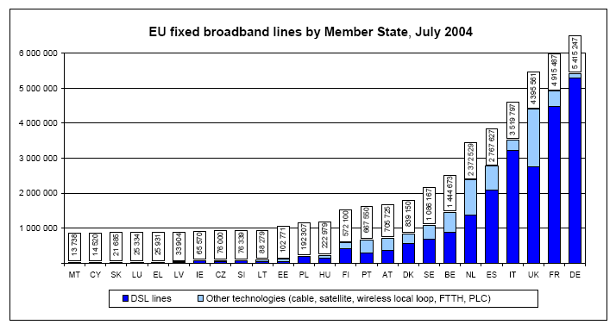

Source: EC 10th Implementation Report

At the same time, cable networks have been identified as the most likely source of real competition to the incumbent telecoms operators in the field of Broadband Internet (and telephony services).

In those Member States where cable networks are present, however, they do offer Broadband Internet services in strong competition to the incumbent telecoms operator but without the same economies of scale and scope as the latter.

In addition, one of the main purposes of the second liberalization phase of the European telecoms markets, implemented through the 2003 New Regulatory Framework, is where effective competition exists, to promote continued deregulation of the sector. The consultation document under discussion, however, seems to contradict this approach by hinting toward increasing the regulatory burden.

Even in situations where certain wholesale offers by the incumbent telecoms operators do not exist yet we do believe that the New Regulatory Framework is adequately equipped to intervene to ensure the market for electronic communications service is open and competitive.

Conclusion:

For the reasons given above, ECCA’s technical report concludes that at current stage of development, cable networks are not capable of offering an equivalent wholesale service to that of bit-stream.

More widely, we are concerned that the broader policy thrust of this consultation – examining the ability for cable to provide a third party wholesale offering – will hamper cable operators ability to competitively restrain incumbent operators in broadband.

ECCA and its members are concerned that the technical consultation may be used by some parties as a means to reopen the open access debate. In the past, such debates have created negative investor sentiment to the detriment of cable operators executing robust, but capital intensive, operations. Accordingly we welcome a balanced and focused assessment of the technology issues at stake in the broadband market.

ECCA hopes that the above and the annex will serve as useful input to the ERG consultation and in general contribute to the creation of strong and sustainable competition across the EU in the electronic communications markets. We also trust that the current consultation will not prejudice the balanced review by the European Commission of the Recommendation on relevant product and services markets which will take place during 2005.

Annex: [Report on the Technical Validity of Bit-stream Access to Cable Networks for Applying ex-ante Regulation]

Report on the Technical Validity of Bit-stream Access to Cable Networks for Applying ex-ante Regulation, in annex.
Market 12 of the Recommendation of 11 February 2003 on relevant product and service markets is wholesale broadband access market. This market covers "bit-stream" access that permit the transmission of broadband data in both directions and other wholesale access provided over other infrastructures, if and when they offer facilities equivalent to bit-stream access.
Mr Erkki Liikanen Member of the European Commission, responsible for Enterprise and the Information Society "Creating a predictable legal environment for competitive and innovative electronic communications in the European Union - Public hearing on remedies under the new regulatory framework for electronic communications networks and services Brussels, 26th January 2004: "infrastructure competition delivers tangible real additional benefits. For this to become a reality, companies must be allowed to compete at the outset using elements of the incumbent's infrastructure."

